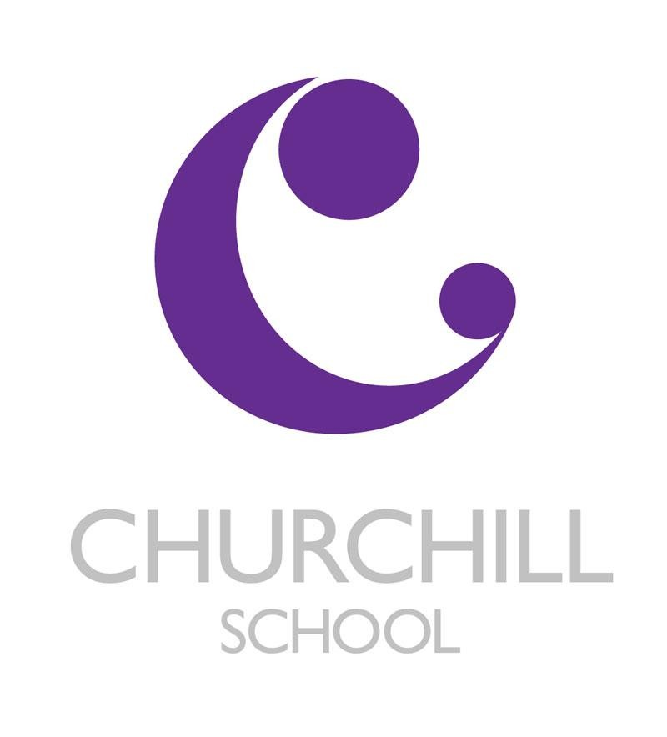

Admissions Arrangements

CHURCHILL SPECIAL FREE SCHOOL: Admissions Arrangements

Type | Day school providing specialist provision for pupils aged 9-18, with Autistic Spectrum Disorder and/or specific communication and language difficulties.
Pupils | We cater for boys and girls aged between 9 and 18 years who either;  - are of average or above average cognitive ability, usually with a diagnosis of language and communication difficulties, high functioning autism, Asperger’s Syndrome, social pragmatic difficulties and those difficulties associated with specific learning difficulties such as dyslexia.  - Are working 3 to 4 years below age related expectations, usually with a diagnosis of language and communication difficulties, social pragmatic difficulties and those difficulties associated with specific learning difficulties such as dyslexia.  The pupils’ needs may be complex, creating significant barriers to learning. They may have associated behavioural difficulties, but they will not have severe learning difficulties or significant social, emotional mental health difficulties.
Access criteria | Discussions between the LA and the School establish if:  • The School is suitable to the child’s age, ability, aptitude and special educational needs  - The child’s placement in the School is compatible with the efficient education of the other pupils with whom the child would be educated  - The placement is an efficient use of resources  - Parents have expressed a preference for the School  The Local Authority names the School in a child’s education and health care plan based on its ability to cater for the child’s specific needs i.e. speech, language and communication difficulties, and/or Autism
Indicative Admissions  criteria | Each application is assessed on an individual basis. In each case, we take account of the needs of the individual child and consider whether the school would be suitable to meet their needs with particular reference to the following factors.  - Pupils will be aged between 9 and 18 years at the time of admission  - The pupil has the potential to access a mainstream curriculum appropriate to their attainment level.  - For the GCSE pathway they will be working at age related expectations.  - For the Blenheim pathway, they will be working at around 3 to 4 years below their chronological age.  - Pupils will have an Education and Health Care Plan (EHCP), specifying that s/he has specific difficulties with language, interaction and communication or a diagnosis of autism.

These further factors will be considered in relation to the two core provision areas of specific language difficulty and autism

Criteria

1. A specific language difficulty relating to receptive language or expressive communication or Sematic Pragmatic Language Disorder.

The pupil will present with many of the following:

- Long term specific language behaviours indicating skills significantly below those of peers
- Limited expressive language that severely limits participation in classroom/setting activities
- Severe difficulties in communicating with peers, leading to social isolation and apparent behaviour difficulties
- Expressive communication that severely limits participation in classroom/setting activities
- Severe difficulties in following instructions, classroom routines and in maintaining attention to tasks, making it impossible for the pupil to participate in most ordinary classroom/setting activities without a high level of support and structure.

OR

- The pupil will have a formal diagnosis of autism

The pupil will demonstrate many of the behaviours (below) which may be ameliorated given appropriate structures and social learning:

- highly atypical behaviour, such as obsessive, inflexible and/or withdrawn behaviours- some severe, linked to communication difficulties
- irrational fears and high anxiety
- inappropriate use of language, abnormal responses to sensory experiences and poor communication leading to substantial evidence of distress or emotional disturbance
- highly inappropriate social behaviour leading to rejection by peers and social isolation, due to speech delay or inability to express themselves
- severe difficulties in communicating with peers, leading to social isolation and apparent behaviour difficulties.
- a high level of frustration caused by the inability to participate in the classroom/setting or interact with peers

Assessment and/or pupil tracking shows that pupils’ projected attainment should be broadly in line with National averages for the GCSE pathway or 3 to 4 years below their chronological age for the Blenheim pathway.
Placement | Placement is full time.

Number of places available | There is a total of 94 full time special educational provision places throughout the school.
Qualifications and methods | - Specialist teachers experienced in working with children with o language, communication and interaction needs.  - Provision of specialist programmes to promote the learning of pupils through the development of communication, social understanding and flexibility of thought;  - Specialist teaching assistants trained in supporting pupils with language, communication and interaction needs  - Access to an occupational therapist  - Access to a speech and language therapist;  - Well-equipped classrooms;  - Access to the National Curriculum, modified where appropriate;  - Access to mainstream resources and lessons, as appropriate  - Emphasis on language rich environment throughout the school
Admissions/ access procedures | The Unity Schools Partnership will admit a child to the Churchill Free Special School, where the Churchill Free Special School is named in the child’s Education and Health Care Plan (EHCP).  Applications for the admission of pupils who live outside Suffolk will be considered, subject to the availability of places and transport decisions by the pupil’s home Local Authority.
Equality | We are committed to providing equality of opportunity and anti-discriminatory practice for all children and families, to providing an environment in which all children are supported to reach their full potential. Applications are considered regardless of gender, religion, background, race or disability.
Admissions arrangements | We admit pupils with an Education and Health Care Plan (EHCP) naming the school.  Places will usually be taken up at the start of the school year, but by arrangement with the Headteacher, places can be accessed at any time of year, where a pupil presents with behaviours consistent with the profile of the School’s provision.  Places are commissioned by the local authority. The total cost of a place will be agreed with the local authority, who will pay the agreed top-up to the £10000 base funding from the DfE.  Parents wishing their child to be considered for a place will be advised to contact their home Local Authority SEN service.  The commissioning LA will consult the Headteacher regarding each pupil the LA considers potentially suitable to request a place in the School.  The Headteacher will consider the suitability of the school provision in addressing the needs of the child and also giving consideration to the needs of the current pupils on roll.
Churchill Special Free School will consent to being named, except where admitting the child would be incompatible with the provision of efficient education for other children; and where no reasonable steps may be made to secure compatibility. Consideration will need to be given to numbers in and the profile of each year group.
In the event that the LA names the School and the School objects to the admission of a pupil based on the criteria, the School is under a contractual obligation to admit the pupil; however, the School is able to make a complaint to the Secretary of State who will evaluate if the LA have fulfilled their statutory and legal duties.
Priorities for admission when  places are limited | - The placement is an efficient use of resources  - The Education and Health Care Plan (EHCP), shows autism to be the primary need.  - Access to specialist subject teaching in mainstream is a vital aspect of provision, particularly for pupils with autism.  - The pupil is in care or being looked after or has previously been looked after
Appeals | Appeals will be to the First-tier Tribunal for statemented pupils. Parents whose children have special educational needs can appeal to the First-tier Tribunal (Special Educational Needs and Disability) against decisions made by Local Authorities in England about their children's education. The application forms and guidance can be found on www.justice.gov.uk/tribunals/send

